English Unit Exam– Unit 2 – “Future”
Grade 2nd - Prof. Rafiel Almanzar - Second Period 2020-2021

Full Name: _____________________________________ AT: _______ Date:______________ Score: ________ / 40 pts.

- Make the following sentences “negative” and “interrogative”. (12 points)

Example: I am going to wear jeans.
Negative: I’m not going to wear jeans.
Interrogative: Are you going to wear jeans?

- You are going to do your homework.
Negative: ______________________________________________________________
Interrogative: ___________________________________________________________

- He is going to text his friends.
Negative: ______________________________________________________________
Interrogative: ___________________________________________________________

- We are going to be late.
Negative: ______________________________________________________________
Interrogative: ___________________________________________________________

- She is going to kiss Steve.
Negative: ______________________________________________________________
Interrogative: ___________________________________________________________

- They are going to watch a movie.
Negative: ______________________________________________________________
Interrogative: ___________________________________________________________

- It is going to rain.
Negative: ______________________________________________________________
Interrogative: ___________________________________________________________

- Complete the sentences with “to be going to” and the “verbs” in brackets: (6 points)
Example: We are going to cook (cook) dinner this evening.

a. He __________________________________ (play) baseball this afternoon.
b. My dog _____________________________ (eat) meat today.
c. Next week, I ___________________________ (visit) my parents.
d. Bryan __________________________________ (buy) a new bike.
e. Danyiberly and Mileyka ________________________________ (watch) the movie tonight.
f. I _________________________________ (go) to the beach tomorrow.
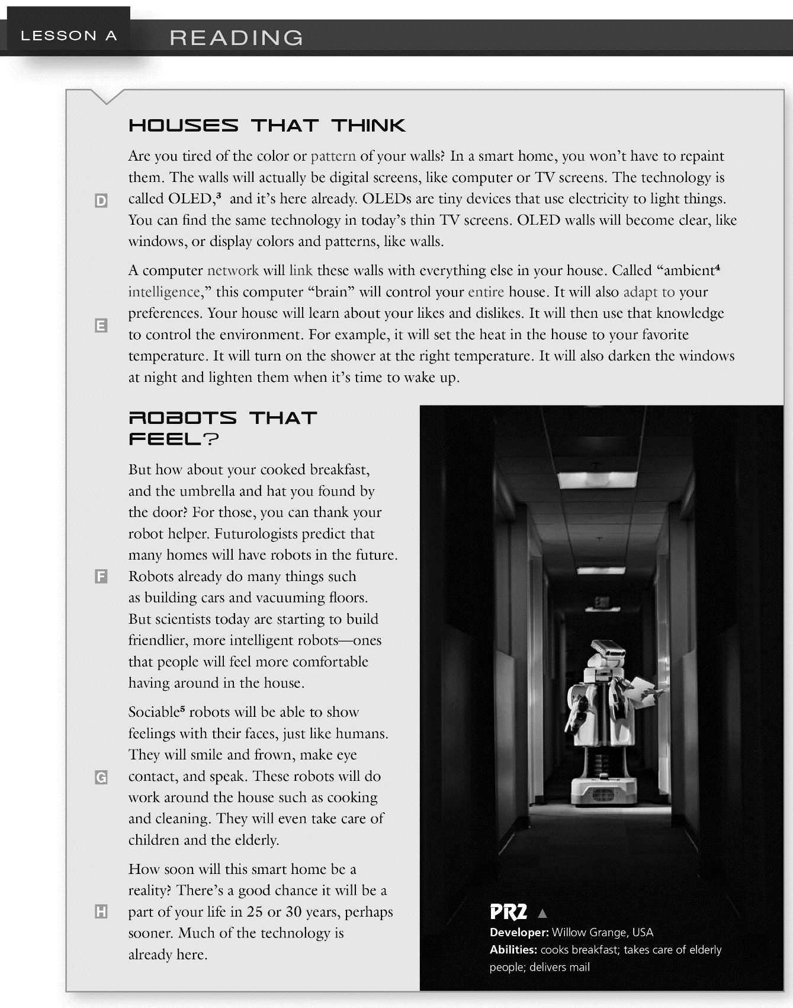
3- Read the following article and answer the following questions: (12 points)

Questions:
- How will Wall be in a smart home? ___________________________________________________________________
- What will robots be able to show with their faces? ___________________________________________________________________
- Will those robots take care of children? ___________________________________________________________________
- What kind of work will those robots do around the house? ___________________________________________________________________
- What a computer network will link the Wall with? ___________________________________________________________________
- Will this computer control the entire house? ___________________________________________________________________
- What will OLED walls do? ___________________________________________________________________
- Will your house learn about your likes and dislikes? ___________________________________________________________________
- What will your house do with that knowledge? ___________________________________________________________________
- What futurologists predict that many homes will have in the future? ___________________________________________________________________
- Will you buy one of those homes if possible? ___________________________________________________________________
- When will the Smart homes be a reality? ___________________________________________________________________
4-Write at least 10 sentences about your plans for the next holy week. (10 points)

Example: For the next holy week, I am going to visit my uncle in Puerto Plata.

________________________________________________________________________________________________________________________________________________________________________________________________________________________________________________________________________________________________________________________________________________________________________________________________________________________________________________________________________________________________________________________________________________________________________________________________________________________________________________________________________________________________________________________________________________________________________________________________________________________________________________________________________________________________________________

