Quarantine Exercises
Lesson 5 – What are they wearing?
Hi guys, I hope you´re having a wonderful day. I also hope that your relatives are doing well and I strongly encourage you to stay at home. I know that having virtual classes is more complex than regular ones, but the more difficult the path is, the more pleasant is the satisfaction once the goal is achieved.
In the following link, you will find the presentation of this assignment:
https://youtu.be/a5EyMpbw0Xc
Please watch the video found in the following link to increase and review the vocabulary for this lesson:
Example 1: https://www.youtube.com/watch?v=_Y_fNXEu0tA
Example 2: https://www.youtube.com/watch?v=YP4d6cdAzu8
After watching the videos above, follow the instructions below.
Instructions:
- Write what people are wearing in each of the following pictures:
Ana | Ana is wearing a black blouse, black heels, a black skirt, a black purse  and a silver watch.
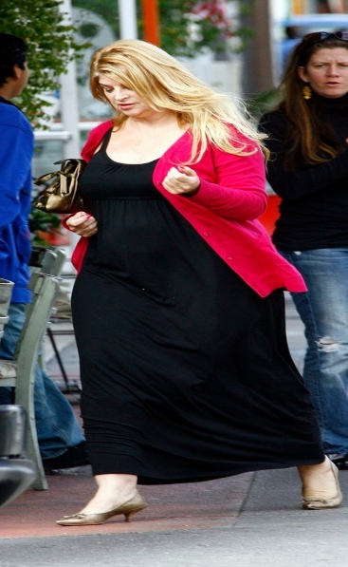  Roquelis | ______________________________  ______________________________  ______________________________  ______________________________
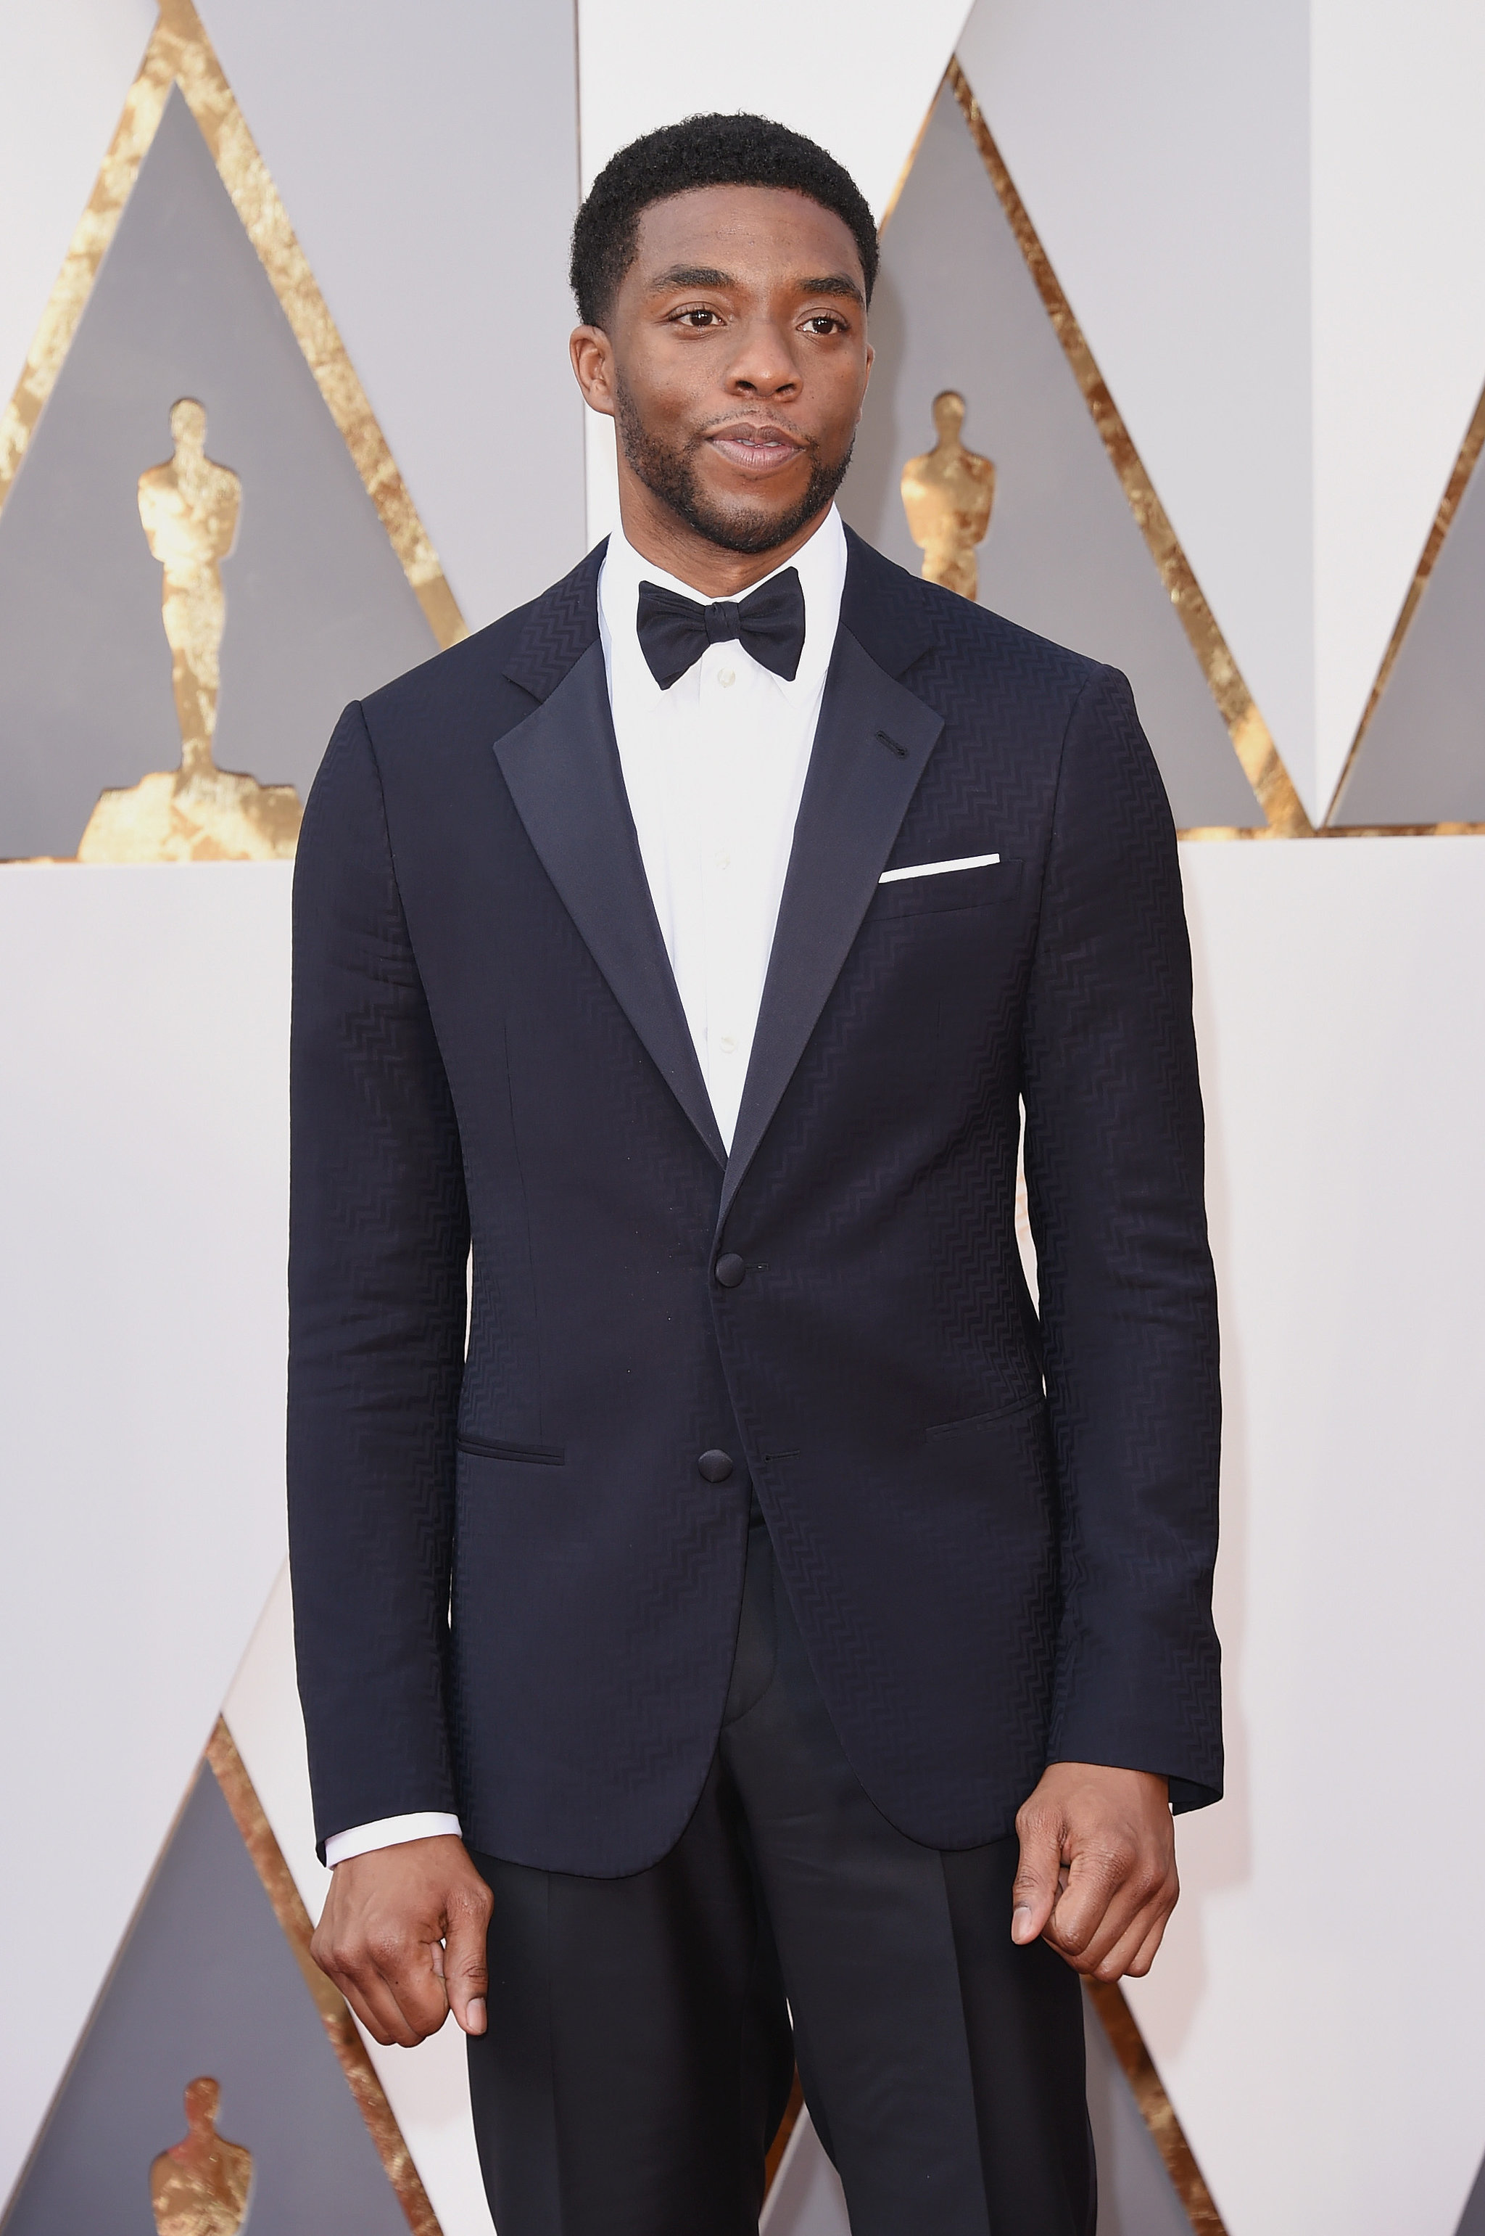  Angel | ______________________________  ______________________________  ______________________________  ______________________________
Devinson | ______________________________  ______________________________  ______________________________  ______________________________
Gonzalo | ______________________________  ______________________________  ______________________________  ______________________________
Rafiel | ______________________________  ______________________________  ______________________________  ______________________________

- Record a video:

Make a video of yourself, saying what you are wearing at that moment, as I did in the presentation of this lesson.

Remember that you have to complete these exercises in your notebook, then you need to take a picture and finally send the picture and the video to me, via email or WhatsApp.

If you have any questions or concerns, please contact me.

