Unit 6 – 1st Grade – Teacher Juleisy Corniel - Third Partial 2019-2020

- What can you see? Check (x) the correct words. (10 pts.)
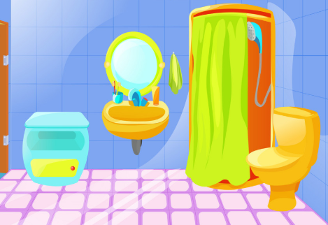
Bathroom
( ) Bathtub
(x) Sink
( ) Toilet
( ) Shower
( ) Bath mat

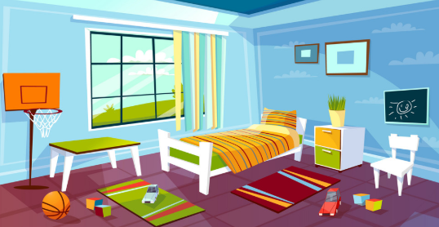
Bedroom
( ) Carpet
( ) Door
( ) Bed
( ) Bedside table
( ) Wardrobe

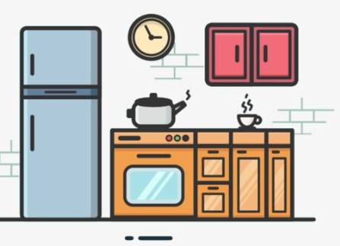
Kitchen
( ) Stove
( ) Fridge
( ) Microwave
( ) Blender
( ) Wastebasket

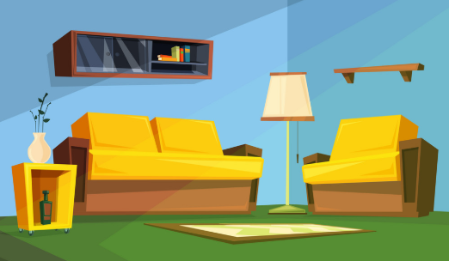
Living room
( ) Armchair
( ) Table
( ) Sofa
( ) TV
( ) Chairs

- Where do you do these things? (10 pts.)
- Watch TV. Living room
- Take a shower.
- Sleep.
- Have lunch.
- Wake up.
- Brush my teeth.
- Have dinner.
- Play.
- Get dressed.
- Do homework.

